Sensing Temperature using RTD
The project expect to produce a data adquisition system for temperature and visualize it using NODERED o Thingsboad.

System Description
Temperatureis the mostessentialfactorthatneedscontinuousmeasurementand monitoring in many process.
Design Specifications
PARAMETERS | SPECIFICATIONS AND FEATURE
Temperature Sensing Range | -30ºC to 100ºC
Measurement Accuracy | < ± 0.1º
ADC resolution and type | 24-bit,ΔΣ ADC with differential inputs
ADC interface for digital data | SPI
RTD Sensor type | 2-, 3-, and 4-wire input
Number of RTD inputs | 4
Current sources and excitation current range | Dual matched current source 0.1 mA
Resistance measurement method | Ratiometric
DC input voltage | 3.3 V
AC power supply | 3.3 V
Indication | LED for the RTD in use.
Interface connectors | 4-pin screw-type terminal block for each RTD  40-pin Socket Connector with long tails  4mm Brass Socket PSU

Block Diagram
The ADS1248 integrates all necessary features (such as dual-matched programmable current sources, buffered reference inputs, PGA, and so forth) to ease the implementation of ratiometric 2-, 3-, and 4-wire RTD measurements.
The general diagram of the system to measure 4 RTDs:
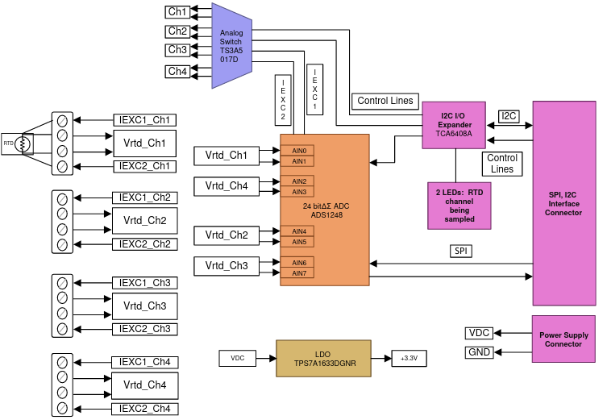

ADC
The design allows to measures of 4 RTDs with an ADS1248. The ADS1248 is a highly-integrated, precision, 24-bit ADC. The ADS1248 features an on board, low-noise, programmable gain amplifier(PGA), a precision ΔΣ ADC with a single-cycle settling digital filter, and an internal oscillator. ADS1248 also provides a built-in, very low-drift voltage reference with a 10-Ma output capacity, and two matched programmable current digital-to-analog converters(DACs). The ADS1248 provides a complete front-end solution for temperature sensor applications including thermal couples, thermistors, and RTDs.
ADS1248 has the following features:
- Four differential inputs.
- Matched current source for RTD excitation
- PGA with gain up to 128
- Internal reference with provision to configure for external reference.
- SPI for configuration and ADC sample reading.
- Chip Select and START to control sampling.

Dual 4:1 Analog Switch
This design uses dual-matched current source. This current is switched between four RTDs. TS3A5017D is used to switch excitation current between RTDs. The TS3A5017is a dual single-pole quadruple-throw (4:1) analog switch that operates from 2.3 to 3.6 V and can handle analog signals

Power Supply
The design runs on +3.3V supply. The supply should be stable. The RPI3, which acts as mezzanine board should prove the +3.3V.

LED Indicators
Four LEDS are provided to indicate the RTD input channel being scanned.

Interfaces
The acquisition system is connected in a sandwich with a RPI3 board which will control the behaviour.

Circuit Design
The 4 RTD inputs are connected to four differential inputs of the ADS1248. The differential inputs are guided to the low noise PGA with a multiplexer.
The PGA provides selectable gain of 1 to 128.
The ∆∑ modulator and adjustable digital filter support up to 2kSPS.
Internal reference and external reference might be selected. The external reference voltage is the differential voltage between REFP and REFN: V_{REF} = V_{REFP} - V_{REFN}.
INCLUIR UN DIAGRAMA CON EL ADC y sus INTERCONEXIONES

3-wire RTD calculation
The most common case is

R_{REF} and PGA gain
The resistance of the PT1000 (NB-PTCO-151) changes from:
-30 ºC | 0 ºC | 30 ºC | 80 ºC | 100 ºC
882.20 Ohm | 1000.00 Ohm | 1116.70 Ohm | 1248.00 Ohm | 1385.10 Ohm

The IDAC current must be 1mA or less to minimize self-heating. The IDAC current chose is I₁ = 500µa.
The resistance swing, is:
1382.10 -1000 = 382.10 Ohm => 382.10 Ohm * 0.500mA =
1000 – 882.20 = 117.8 Ohm => 117.8 Ohm * 0.500mA =

Then the maximum and minimum input voltage to the PGA are (assuming R_{LEAD} = 0Ω):

VIN_{MAX}= 1382.10 Ohm * 0.500mA = 691.05 mV
VIN_{MAX}= 882.20 Ohm * 0.500mA = 441.1 mV
The external reference resistor R_{REF} should be a precision low-drift reference resistor. It serves two purposes:
- It decides the external reference voltage for ADC
- It also determines the input common mode voltage of the PGA.
Set the common mode voltage around mid-supply (AVDD– AVSS)/ 2 = (3 V – 0 V) / 2 = 1.65V. Therefore, the reference voltage chosen
V_{REF}=2 V, V_{REF}=1.5, V_{REF}=2.2V
which also depends on easily available resistance value and excitation current.
V_{REF} = (IDAC1 + IDAC2) * R_{REF}
Because IDAC1 = IDAC2 = 0.500mA => V_{REF} = 2* IDAC1 * R_{REF}
R_{REF} = V_{REF}/(2*IDAC1) = 2V (2* 0.500mA) = 2KOhm
R_{REF} = V_{REF}/(2*IDAC1) = 1.5V (2* 0.500mA) = 1.5KOhm
R_{REF} = V_{REF}/(2*IDAC1) = 2.2V (2* 0.500mA) = 2.2KOhm

GAIN_{PGA}= VREF/ VIN_{MAX}= 2V/691.05 mV = 2.8941 => The nearest G=2
GAIN_{PGA}= VREF/ VIN_{MAX}= 1.5V/691.05 mV = 2.1706 => The nearest G=2 !!! Max temp 90º!
GAIN_{PGA}= VREF/ VIN_{MAX}= 2.2V/691.05 mV = 3.1836 => The nearest G=2

Common-Mode voltage compliance check
he signalof an RTDis of a pseudo-differentialnature,wherethe negativeinputmustbe biasedat avoltageotherthan0 V and the positiveinputcan thenswingup to 97.04mV abovethe negativeinput.The allowedcommon-modeinputvoltagerangeis as highlightedin Figure10 (takenfromthe ADS1248datasheet
AVSS+0.1 + (V_{IN}*Gain) /2 ≤ V_{CMI} ≤ AVDD-0.1 - (V_{IN}*Gain) /2
AVSS = 0; V_{IN} = 58.9 Mv; Gain = 2; AVDD = 3.3 V; IDAC=0.500mA
V_{CMI_MIN}= AVSS+0.1V+VIN GAIN/2 = 0V + 0.1V + (58.9mV *8)/2 = 100mV + 235.6mV = 335.6 mV
V_{CMI_MAX}= AVDD- 0.1 - (V_{IN}*Gain)/2 = 3.3V – 0.1V – (191.05mV*8)/2 = 3.3V - 100mV - 764.2mV = 3.3V -864.2 mV = 2.4358 V
R_{RTD} = 1385.10 Ohm
V_{CMI_MIN_GAIN}= (IDAC*R_{LEAD})+ IDAC*R_{RTD}/2+2*IDAC*(R_{LEAD}+R_{REF})= 0.500mA*1385.10/2 + 2* 0.500mA*2K=0.346+2= 2.346V
V_{CMI_MIN_GAIN}= (IDAC*R_{LEAD})+ IDAC*R_{RTD}/2+2*IDAC*(R_{LEAD}+R_{REF})= 0.500mA*1385.10/2 + 2* 0.500mA*1.5K=0.346+1.5= 1.846V
V_{CMI_MIN_GAIN}= (IDAC*R_{LEAD})+ IDAC*R_{RTD}/2+2*IDAC*(R_{LEAD}+R_{REF})= 0.500mA*1385.10/2 + 2* 0.500mA*1.5K=0.346+2.2= 2.546V
R_{RTD} = 882.20 Ohm
V_{CMI_MAX_GAIN}= (IDAC*R_{LEAD})+ IDAC*R_{RTD}/2+2*IDAC*(R_{LEAD}+R_{REF})= 0.500mA*882.20/2 + 2* 0.500mA*2K=0.220+2= 2.220V
V_{CMI_MAX_GAIN}= (IDAC*R_{LEAD})+ IDAC*R_{RTD}/2+2*IDAC*(R_{LEAD}+R_{REF})= 0.500mA*882.20/2 + 2* 0.500mA*1.5K=0.220+1.5= 1.720V
V_{CMI_MAX_GAIN}= (IDAC*R_{LEAD})+ IDAC*R_{RTD}/2+2*IDAC*(R_{LEAD}+R_{REF})= 0.500mA*882.20/2 + 2* 0.500mA*1.5K=0.220+2.2= 2.420V
Solo cumplimos con el valor de RREF=2K
Si reducimos la amplificaion.

Noise consideration and Input filter
ToBe Understood

Multiplexer
is usedto switchexcitationcurrentfor all the RTDs.

RTD Resistance Measurement
RTD resistance value changes with the temperature for NB-PTCO-151:
-30 ºC | 0 ºC | 30 ºC | 80 ºC | 100 ºC
882.20 Ohm | 1000.00 Ohm | 1116.70 Ohm | 1248.00 Ohm | 1385.10 Ohm

Current source: PTD biasing
While maximizing the magnitude of the excitation current would seem desirable, higher excitation currents create higher power-dissipation leading to self-heating of the RTD.
I₁ = 01. mA
The typical range of RTD self-heating coefficients is 2.5mW/°C for small elements to 65mW/°C for larger elements.

Ratiometric Measurement
If we reference the ADC with the same supply as the RTD, the noise on the supply will cancel due to the differential measurement.
The excitation current that flows through the RTD returns to ground through a low-side reference resistor, R_{REF} .

Amplification PGA
By choosing a smaller value for the excitation current, reducing self-heating, the RTD produces a small change in voltage over the span of the temperature measurement which will not use the full ADC input range.
The RTD signal is a pseudo-differential signal, it never goes below 0. Requirements to stay sin the linear operating range of the PGA:
AVSS + 0.1 V ≤ V (OUTN) , V (OUTP) ≤ AVDD – 0.1 V
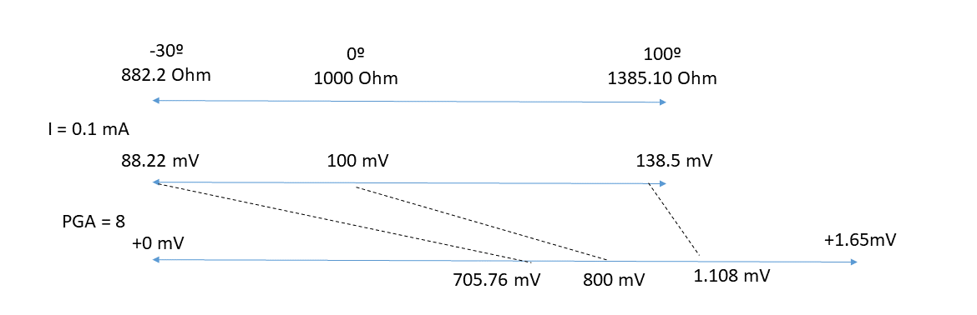

Equation 11 and 12:
VCM_{MIN}=> VSS- 0.1 + 1/2 *G* VIN_{MAX}=0.1

Digital Filter

